
Bird Migration/Migración de aves
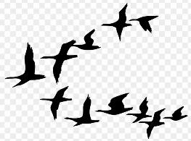

Activity 1/Actividad 1: Read about bird migration from the two different articles. Compare the two information sources and answer the following questions in your science notebook.
Lee del micración de las aves en dos artículos diferentes. Compara los dos fuentes de información y escribe sus respuestas de las preguntas en su cuaderno de ciencia.
- What is migration? Why do animals migrate?
¿Qué es la migración? ¿Por qué los animales migran?
- How do animals know when to migrate?
¿Cómo saben los animales cuándo migrar?
Activity 2/Actividad 2: Draw a comic that shows how birds react to changes in their environment, and know when to migrate. Dibuja un comic que muestra como las aves reacciona a cambios en su ambiente, y saben cuando migrar.
Example/Ejemplo:
- Input | - Processing | - Response
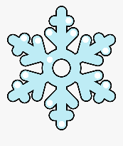  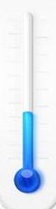   |   I feel cold.  Hace frio. |     I’m cold, so I will  put on a coat!  ¡Hace frio,  entonces lleva  una chaqueta!
Copy this chart into your science notebook, then fill out the boxes with your own migration comic.
Hace una copia de la charta en su cuaderno de ciencia. Siguente, completa las cajas con su comic de migración.
- Input | - Processing | - Response

Learn more about migration on Audubon for Kids! Aprende más de la migación en Audubon para Niños.
- Game: Follow a Bird's Migration Story / Juego: Sigue la historia de migración de un ave
- Quiz: What do you know about migration?
- Watch a video about Hawk and Eagle migration in the Manzano Mountains

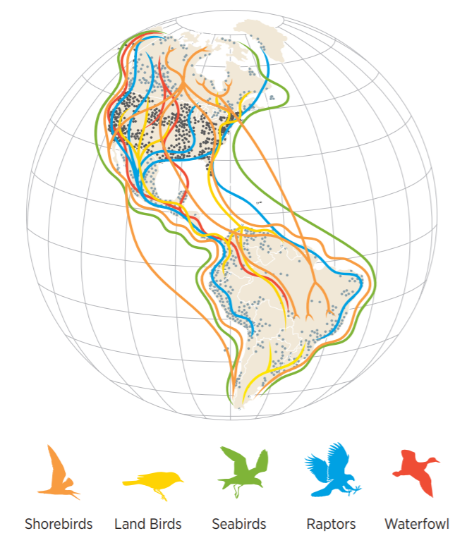
Every year in spring and fall, millions of birds migrate, taking to the air to travel between their summer and winter homes. It’s a relatively short trip for some. Others travel thousands of miles, sometimes flying for days without landing. Different birds use different skills to get where they need to go. Some learn from their parents. Others use landmarks, sound, the sun and stars, or Earth’s magnetic field to find their way.
Cada año en primavera y otoño, millones de aves migran, tomando el aire para viajar entre sus hogares de verano e invierno. Es un viaje relativamente corto para algunos. Otras viajan miles de kilómetros, a veces volando durante días sin aterrizar. Diferentes aves usan diferentes habilidades para llegar a donde necesitan ir. Algunas aprenden de sus padres. Otras usan puntos de referencia, el sonido, el sol y las estrellas, o el campo magnético de la Tierra para encontrar su camino.

How Do Birds Find Their Way?
From Audubon Adventures: Birds on the Move
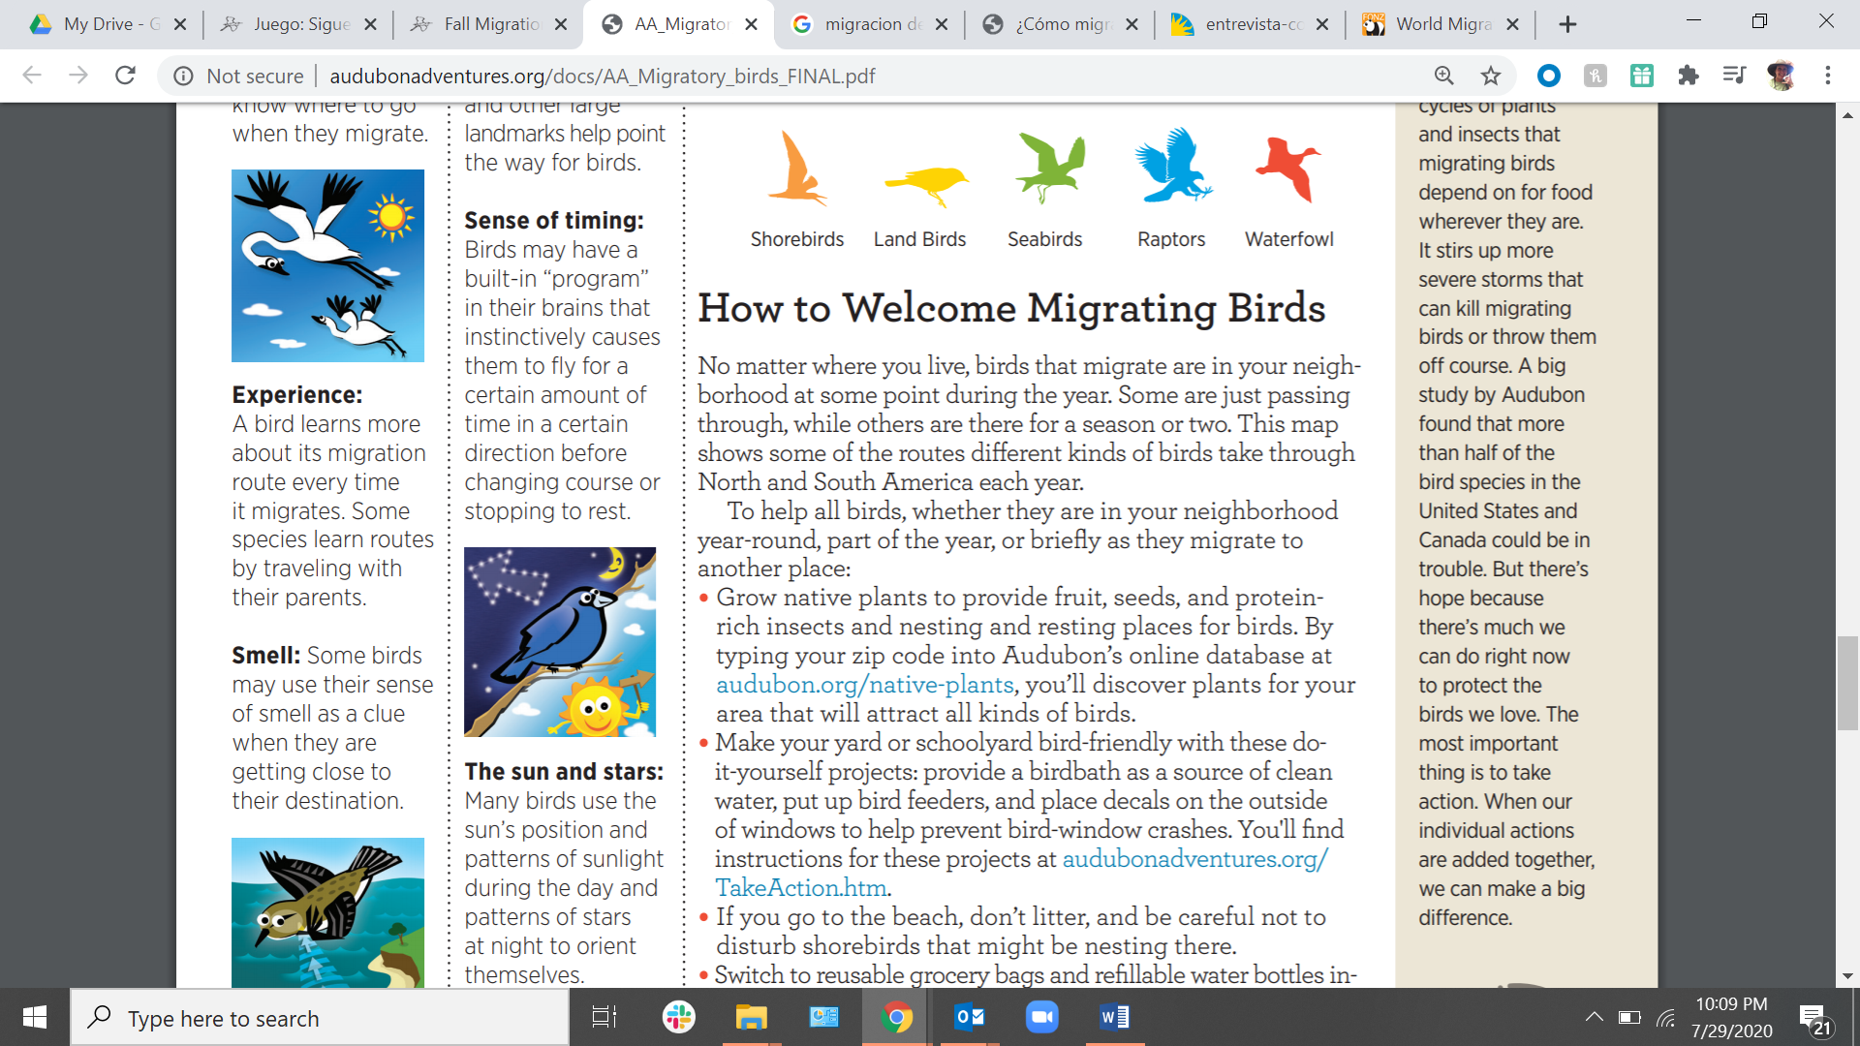
Migratory birds don’t have navigation systems like airplane pilots do to tell them when to turn. They must use other clues to help them find their way. First, they need to know where they are and which direction is the correct way to go. This is called orientation. Next, they need to follow the correct route. This is called navigation. Scientists have learned a lot about how birds orient themselves and navigate.
Instinct: A bird is born with built-in knowledge called instinct. Some species instinctively know where to go when they migrate.
Experience: A bird learns more about its migration route every time it migrates. Some species learn routes by traveling with their parents.
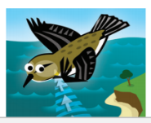
Smell: Some birds may use their sense of smell as a clue when they are getting close to their destination
Sound: Birds may use the sound of waves on coastlines and winds flowing over mountains as guides.
Landmarks: Mountains, rivers, and other large landmarks help point the way for birds.
Sense of timing: Birds may have a built-in “program” in their brains that instinctively causes them to fly for a certain amount of time in a certain direction before changing course or stopping to rest.
The sun and stars: Many birds use the sun’s position and patterns of sunlight during the day and patterns of stars at night to orient themselves.
Magnetism: Birds can sense Earth’s magnetic field and use it as a compass.

