Distance Learning Lesson 4
4th Grade
Feet & Feathers

Time Estimate: 1 hour

Vocabulary:
- Feathers
- Behavior
- Habitat
- Adaptation
- Feet
- Talons

Required materials:
- Paper
- Pencil
- Student worksheets
- Goose Feather x 2
- Pipette
- Water
- Cooking oil (any kind)

Focus Question: How does a bird’s feet and feathers allow it to survive in its habitat?
- Bird feet are specially adapted to help it survive in its habitat. Duck feet are webbed to help it swim, while hawks have sharp talons to help them catch and kill their prey.
- Bird feathers are also specially adapted to help birds survive. Birds have many different types of feathers that are useful in different ways. What all are feathers useful for?
  - Flying
  - Staying warm & dry
  - Camouflage
  - Attracting a mate

Investigation 1: Students will examine different types of feathers and feet of various birds and determine what they are adapted to do.
- Using images on their worksheets, students will compare different types of feathers to determine how they are adapted to help the bird survive.
- Using images on their worksheets, students will compare different bird feet to determine how they are adapted to help the bird survive.
Video Link: Bird Feet comparison

Investigation 2: Students will conduct an experiment to determine how feathers are useful in waterproofing for birds that live in wet habitats.

Video Link: Bird Preening
- Birds have a special oil-producing gland at the base of their tail called the ‘preen gland’. They use this oil to coat their feathers with their beaks, a behavior called ‘preening’. This helps to keep their feathers clean and waterproof! For birds that spend a lot of time in the water, like geese and ducks, this is especially important to keep them dry and warm.
- Sadly, this waterproofing does not protect birds from oil. That is why oil spills from boats or pipelines can be so devastating to birds. They have a very hard time cleaning these heavy oils off their feathers.
- Students will compare what happens to their goose feather when they pipette water droplets and oil droplets onto the goose feathers.
- Reflection questions:
  - What happened to the drops of water that fell on the feather? What about the drops of oil?
  - Why are geese feathers adapted in this way?
  - What do you think might happen to a goose if oil gets in the water where they live?

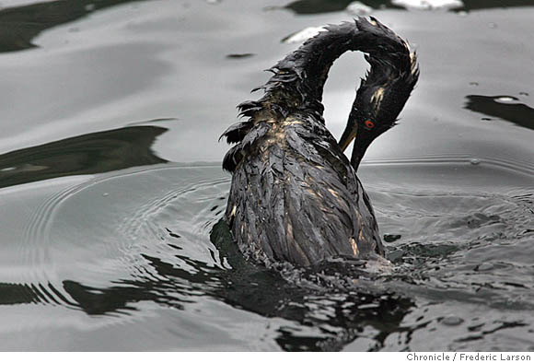
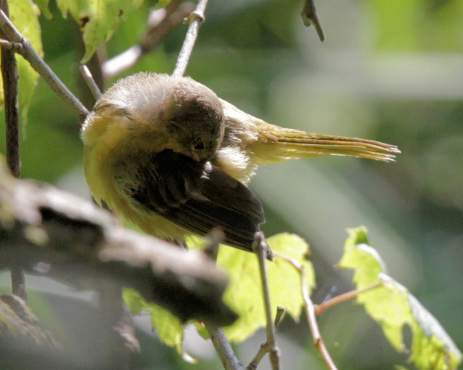
Images: Bird preening (left), bird covered in oil after an oil spill (right)

Next Generation Science Standards Supported:
- 4-LS1-1. Construct an argument that plants and animals have internal and external structures that function to support survival, growth, behavior, and reproduction.

Common Core Standards Supported:
- CCSS.ELA-LITERACY.RI.4.4 Determine the meaning of general academic and domain-specific words or phrases in a text relevant to a grade 4 topic or subject area.
- CCSS.ELA-LITERACY.RI.4.7 Interpret information presented visually, orally, or quantitatively (e.g., in charts, graphs, diagrams, time lines, animations, or interactive elements on Web pages) and explain how the information contributes to an understanding of the text in which it appears.

