Distance Learning Lesson 2
4th Grade
Why can’t humans fly?

Time Estimate: 1 hour

Vocabulary:
- Rate
- Wing beat
- Flap speed
- Internal
- Features
- Bones
- Wingspan

Required materials:
- Paper
- Pencil
- Clock, watch, or timer

Focus Question: Why can’t humans fly? What internal features allow birds to fly?
- Birds have hollow bones! With hollow bones, birds are much lighter than other animals, allowing them to fly more easily.
  - Birds have a large bone in their chest called the keel, a strong pectoral bone with muscle anchored in it, which allows for strong and efficient movement.
  - Air sacs around bones also help move oxygen through bodies more efficiently.
  - Birds don’t have teeth nor fat stores, which add weight to the body.
  - Refer to bird skeletal diagram below.
- Not all birds fly in the same way. Turkey Vultures soar for hours without flapping their wings very often, while hummingbirds flap their wings over 200 times a second as they fly forward, hover in place, and even fly backwards!

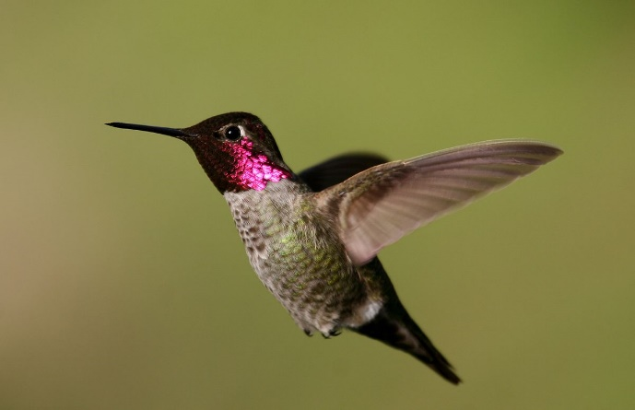
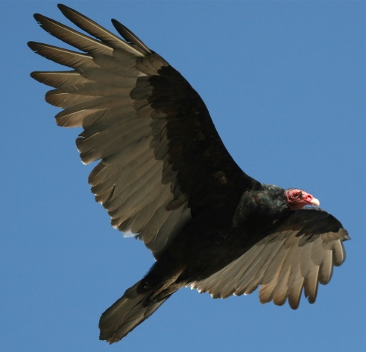
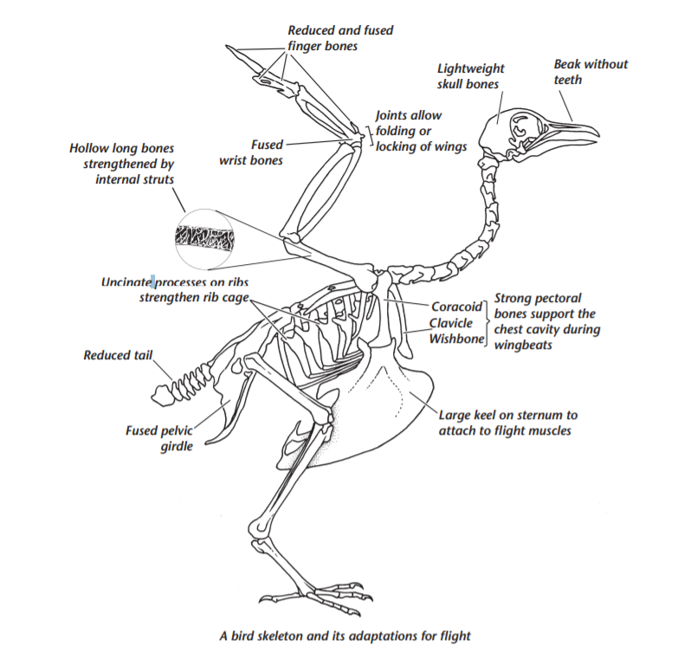
Below are videos to assist in further explaining different flight behaviors of three different birds, specifically in the use of their wings.
- Video Links: Turkey Vulture Flight Behavior, Rufous Hummingbird Flight Behavior, and Northern Flicker Flight Behavior

Investigation 1: Students will measure their wingbeat rate.
- Students will hold out their arms as if they are wings and have someone at home time them for 10 seconds of flapping. They will flap as fast as they can, counting each flap.
- Students will record their data and use it to calculate their wingbeats per minute using the chart below. Students can ask siblings or other family members to measure their wingbeat rate and compare to their own.
- Students will use their wingbeat chart data to determine which local bird most closely matches their wingbeat rate according to the table on their worksheet.

Name | Number of flaps per 10 seconds | X6 = Number of flaps in 1 minute | Most similar bird | Least similar bird

Next Generation Science Standards Supported:
- 4-LS1-1. Construct an argument that plants and animals have internal and external structures that function to support survival, growth, behavior, and reproduction.

Common Core State Standards Supported:
- CCSS.ELA-LITERACY.RI.4.3 Explain events, procedures, ideas, or concepts in a historical, scientific, or technical text, including what happened and why, based on specific information in the text.
- CCSS.ELA-LITERACY.RI.4.4 Determine the meaning of general academic and domain-specific words or phrases in a text relevant to a grade 4 topic or subject area.
- CCSS.ELA-LITERACY.RI.4.7 Interpret information presented visually, orally, or quantitatively (e.g., in charts, graphs, diagrams, time lines, animations, or interactive elements on Web pages) and explain how the information contributes to an understanding of the text in which it appears.

