Adopt a Plant
Remote Lesson 5

Go into your neighborhood, park, or yard and find a plant you would like to learn more about.

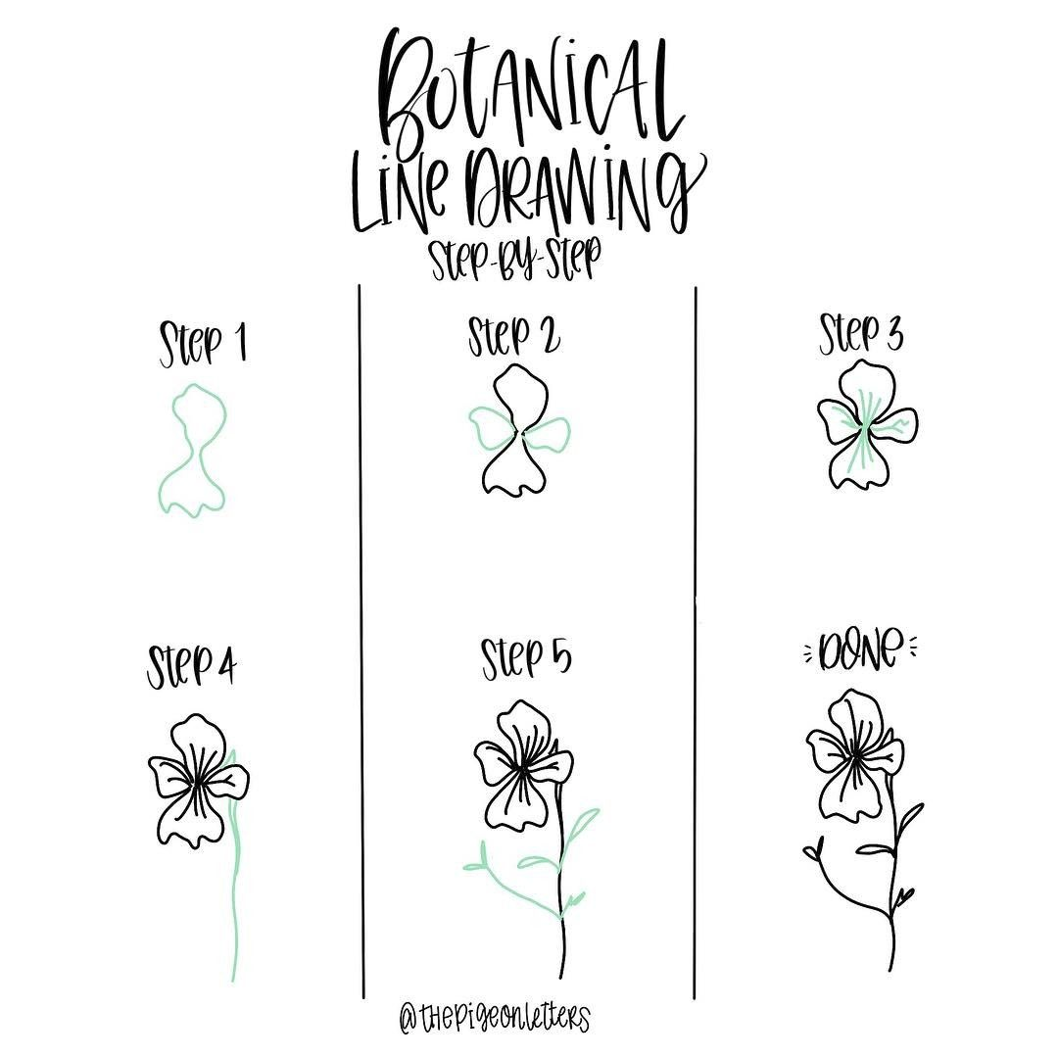
Instructions for Botanical Drawings
- Look closely at your plant
- What shapes do you see?
- Start with simple shapes and then add more detail
- Include pictures of the whole plant and details like seeds, flowers, leaves, and roots

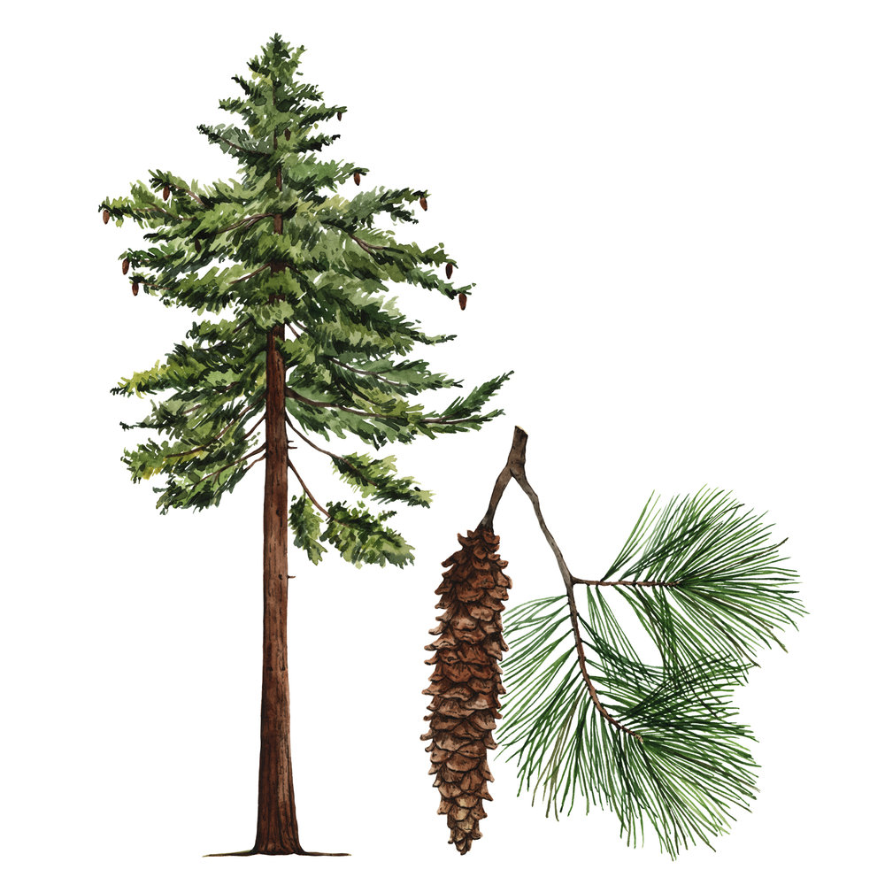
In your journal make sure you include...
- Date, time, weather, and location
- What does your plant look like? Draw it and make notes.
- What types of soil are around your plant? If you need to, go back and do a new soil test.
- How does your plant get water?
- How much sun does your plant get?
- What type of microclimate is it in?
- What other questions do you have about your plant?
