Journaling Instructions for Students

Investigate your neighborhood, yard, or local park. Walk around and look for different microclimates. Make sure you ask your adult before going out!
Materials:
- Journal
- Art supplies
- Hat, water, sunscreen
Look for places that:
- Are along a wall and are warmer or colder than the surrounding area
- Might get a lot of shade
- Get extra water from a hose or a canale
- Have a lot of plants growing
- Have very few plants growing
Instructions for your journal:
- Draw 3 different microclimate habitats.
- Observe each habitat for at least 10-15 minutes.
- Include the way the soil feels and looks. Is it warm or cool? Wet or dry? Sandy, loamy, or clay?
- What plants are growing there. Draw them.
- If you see any animals, including birds and insects.
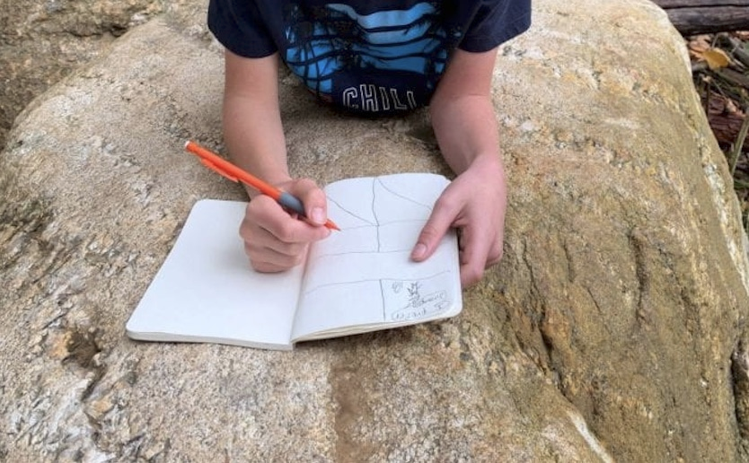
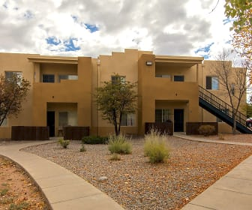
- Include anything else you think is important to notice.

