Student Soil Investigation

Today you are going to investigate the soil around where you live.

Step 1: Collect soil samples
- Look around the area where you want to learn about the soil
- Find three different types of soil. For example, look at the soil under a tree, in a ditch, and in a bare sandy area.
- Collect samples and put them each in a bag
- Label each bag

Step 2: Record where each sample is from in your journal
- Draw a quick sketch of where you collected each sample and label each sketch
- Make a note of what kinds of plants grow there, if water flows through the area, and anything else you think is important to include

Step 3: Prepare the soil for the tests.
- Pull any large rocks, leaves, sticks, roots, or trash out of the bags of soil
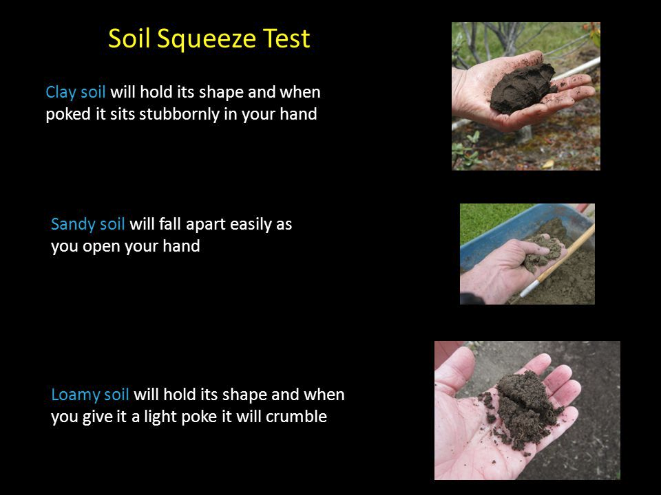
SQUEEZE TEST
- Take a handful of soil and add a little water
- Make a fist around the wet soil
- Open your hand
  - If it will hold its shape, and, when poked, sits stubbornly in your hand. This means you have clay soil.
  - If it will hold its shape, and when you give it a light poke, it crumbles. Lucky you—this means you have luxurious loam!
  - If it will fall apart as soon as you open your hand. This means you have sandy soil.
- Record your results in the journal

SHAKE TEST - Record your results in your journal
