Student Nature Journal Instructions and Prompts

Below are some ideas to help you get started with your own Nature Journal!

Instructions:
- Choose a location that you want to visit every week and bring a chair or pillow to get comfortable there
- Bring your journal, pencil, art materials, hat, water, and sunscreen.
- Every time you go out to do an entry in the journal, make sure you include:
  - Date
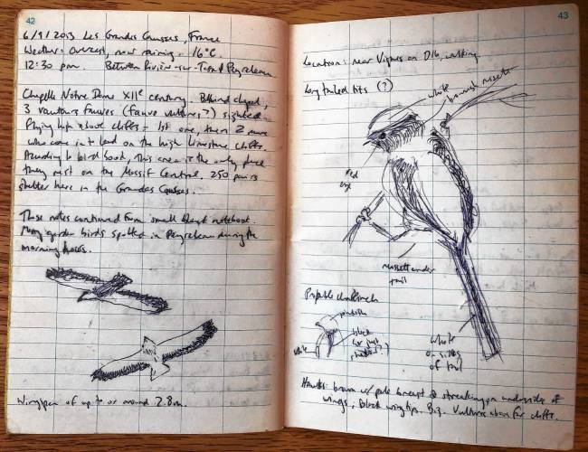
  - Time
  - Weather
  - Location
- Each time, you might include different things, including:
  - Drawings
      - small details of plants and animals
      - large views
  - Writing
      - see
      - smell
      - hear
      - feel
  - Anything else you want to record

Ideas for your Nature Journal:
- What is the smallest thing you see? Look at it closely and draw and label it.
- How many colors do you see? Can you draw them?
- Spend 30 seconds sitting by an open window with your eyes closed. What sounds do you hear? Can you write down the sounds? Can you draw the sounds?
- Can you write a story from the perspective of a bird? How does a bird see the world differently?
- Weather-Watching: Record the weather at three different times of the day or the week. What did you notice? Can you draw it?
- Think about your favorite place in nature. What makes it special? Can you draw or write about how you feel when you visit that special place? Is there something special, like a pine spill or leaf you can glue in your journal to remind you of that special feeling?
- Draw a leaf that you find or make a leave rubbing. Now, try one with a different leaf. What is similar about the two leaves? What is different?
- Can you find an ant and trace its path?
- If you can go outside, draw any tracks you see. Record any other signs of animals you find, as well.
- Take a walk around the block. How many tree species do you see? Can you make a map of your block or neighborhood, and include the different trees?

