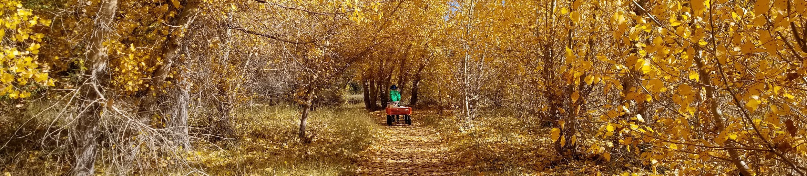Explore what makes nature amazing with the Santa Fe Botanical Garden!
You are going to learn about the environment around you through looking closely, exploring, and having fun!

About the Santa Fe Botanical Garden
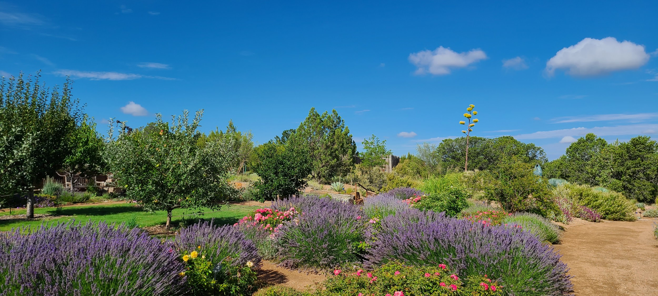
A botanical garden is like a museum for plants. Gardens care for the plants and help them grow. The Santa Fe Botanical Garden has a collection of plants that grow well in Santa Fe. It is still a new garden. It was planted in 2013. What year were you born? Is the Botanical Garden older or younger than you?
The garden was designed by a landscape architect named Gary Smith. He wanted to create a garden that helps connect nature and people. If you could build a garden, what would you include? Why? In your nature journal, draw your dream garden. What plants would you include?
You can learn more about the Santa Fe Botanical Garden at santafebotanicalgarden.org (Links to an external site.).

