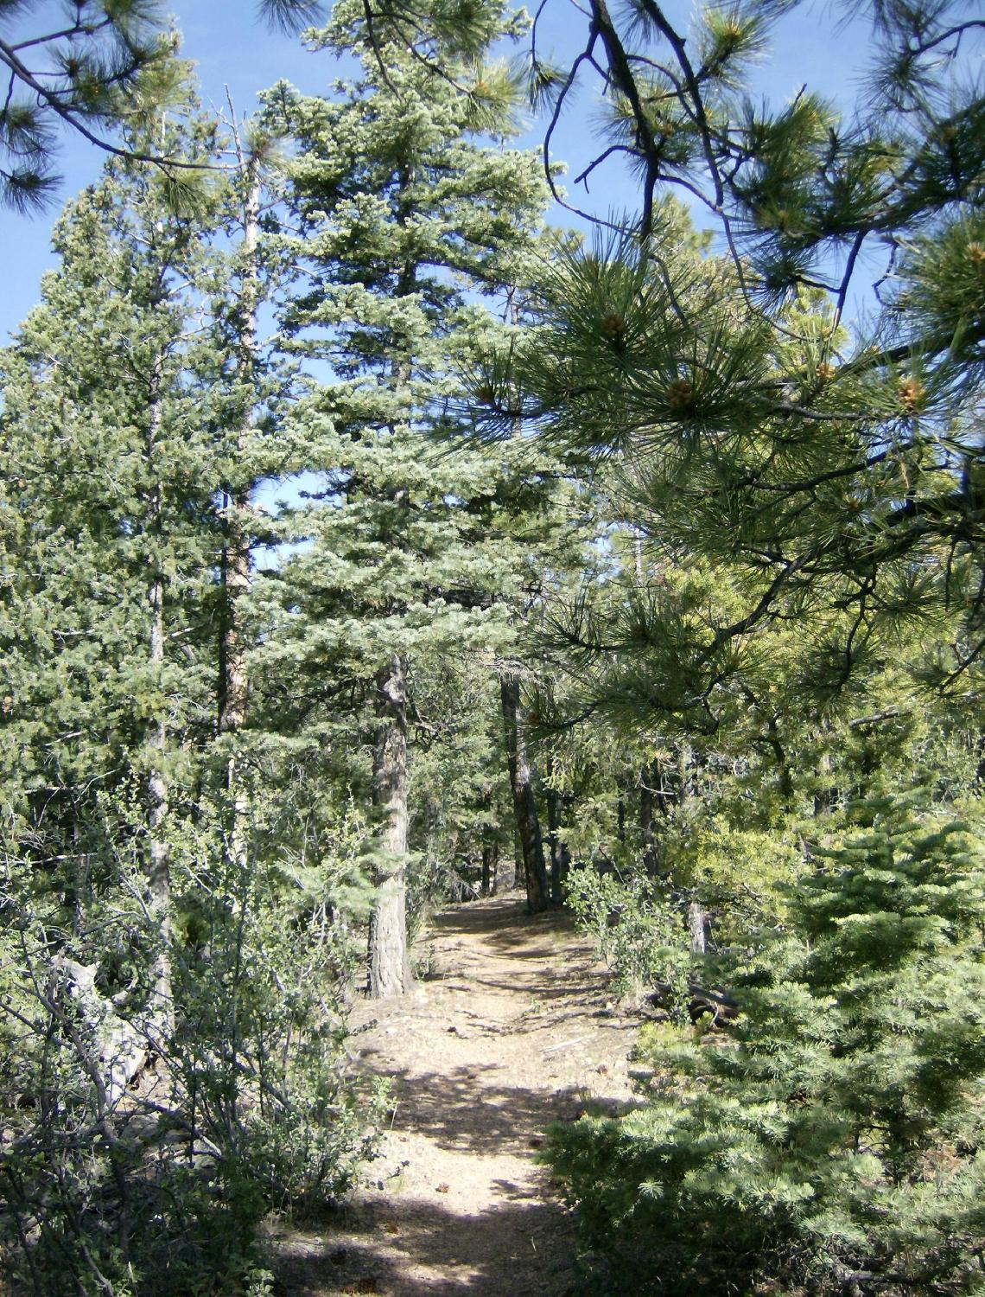
Forest – Forests cover about one third of the Earth’s land. Forests support a large variety of animal life. They are filled with deciduous and evergreen trees, which produce berries and seeds. Some animals that live in Santa Fe’s forests include: foxes, bears, coyotes, rabbits, mice, lizards, birds, and different types of insects.

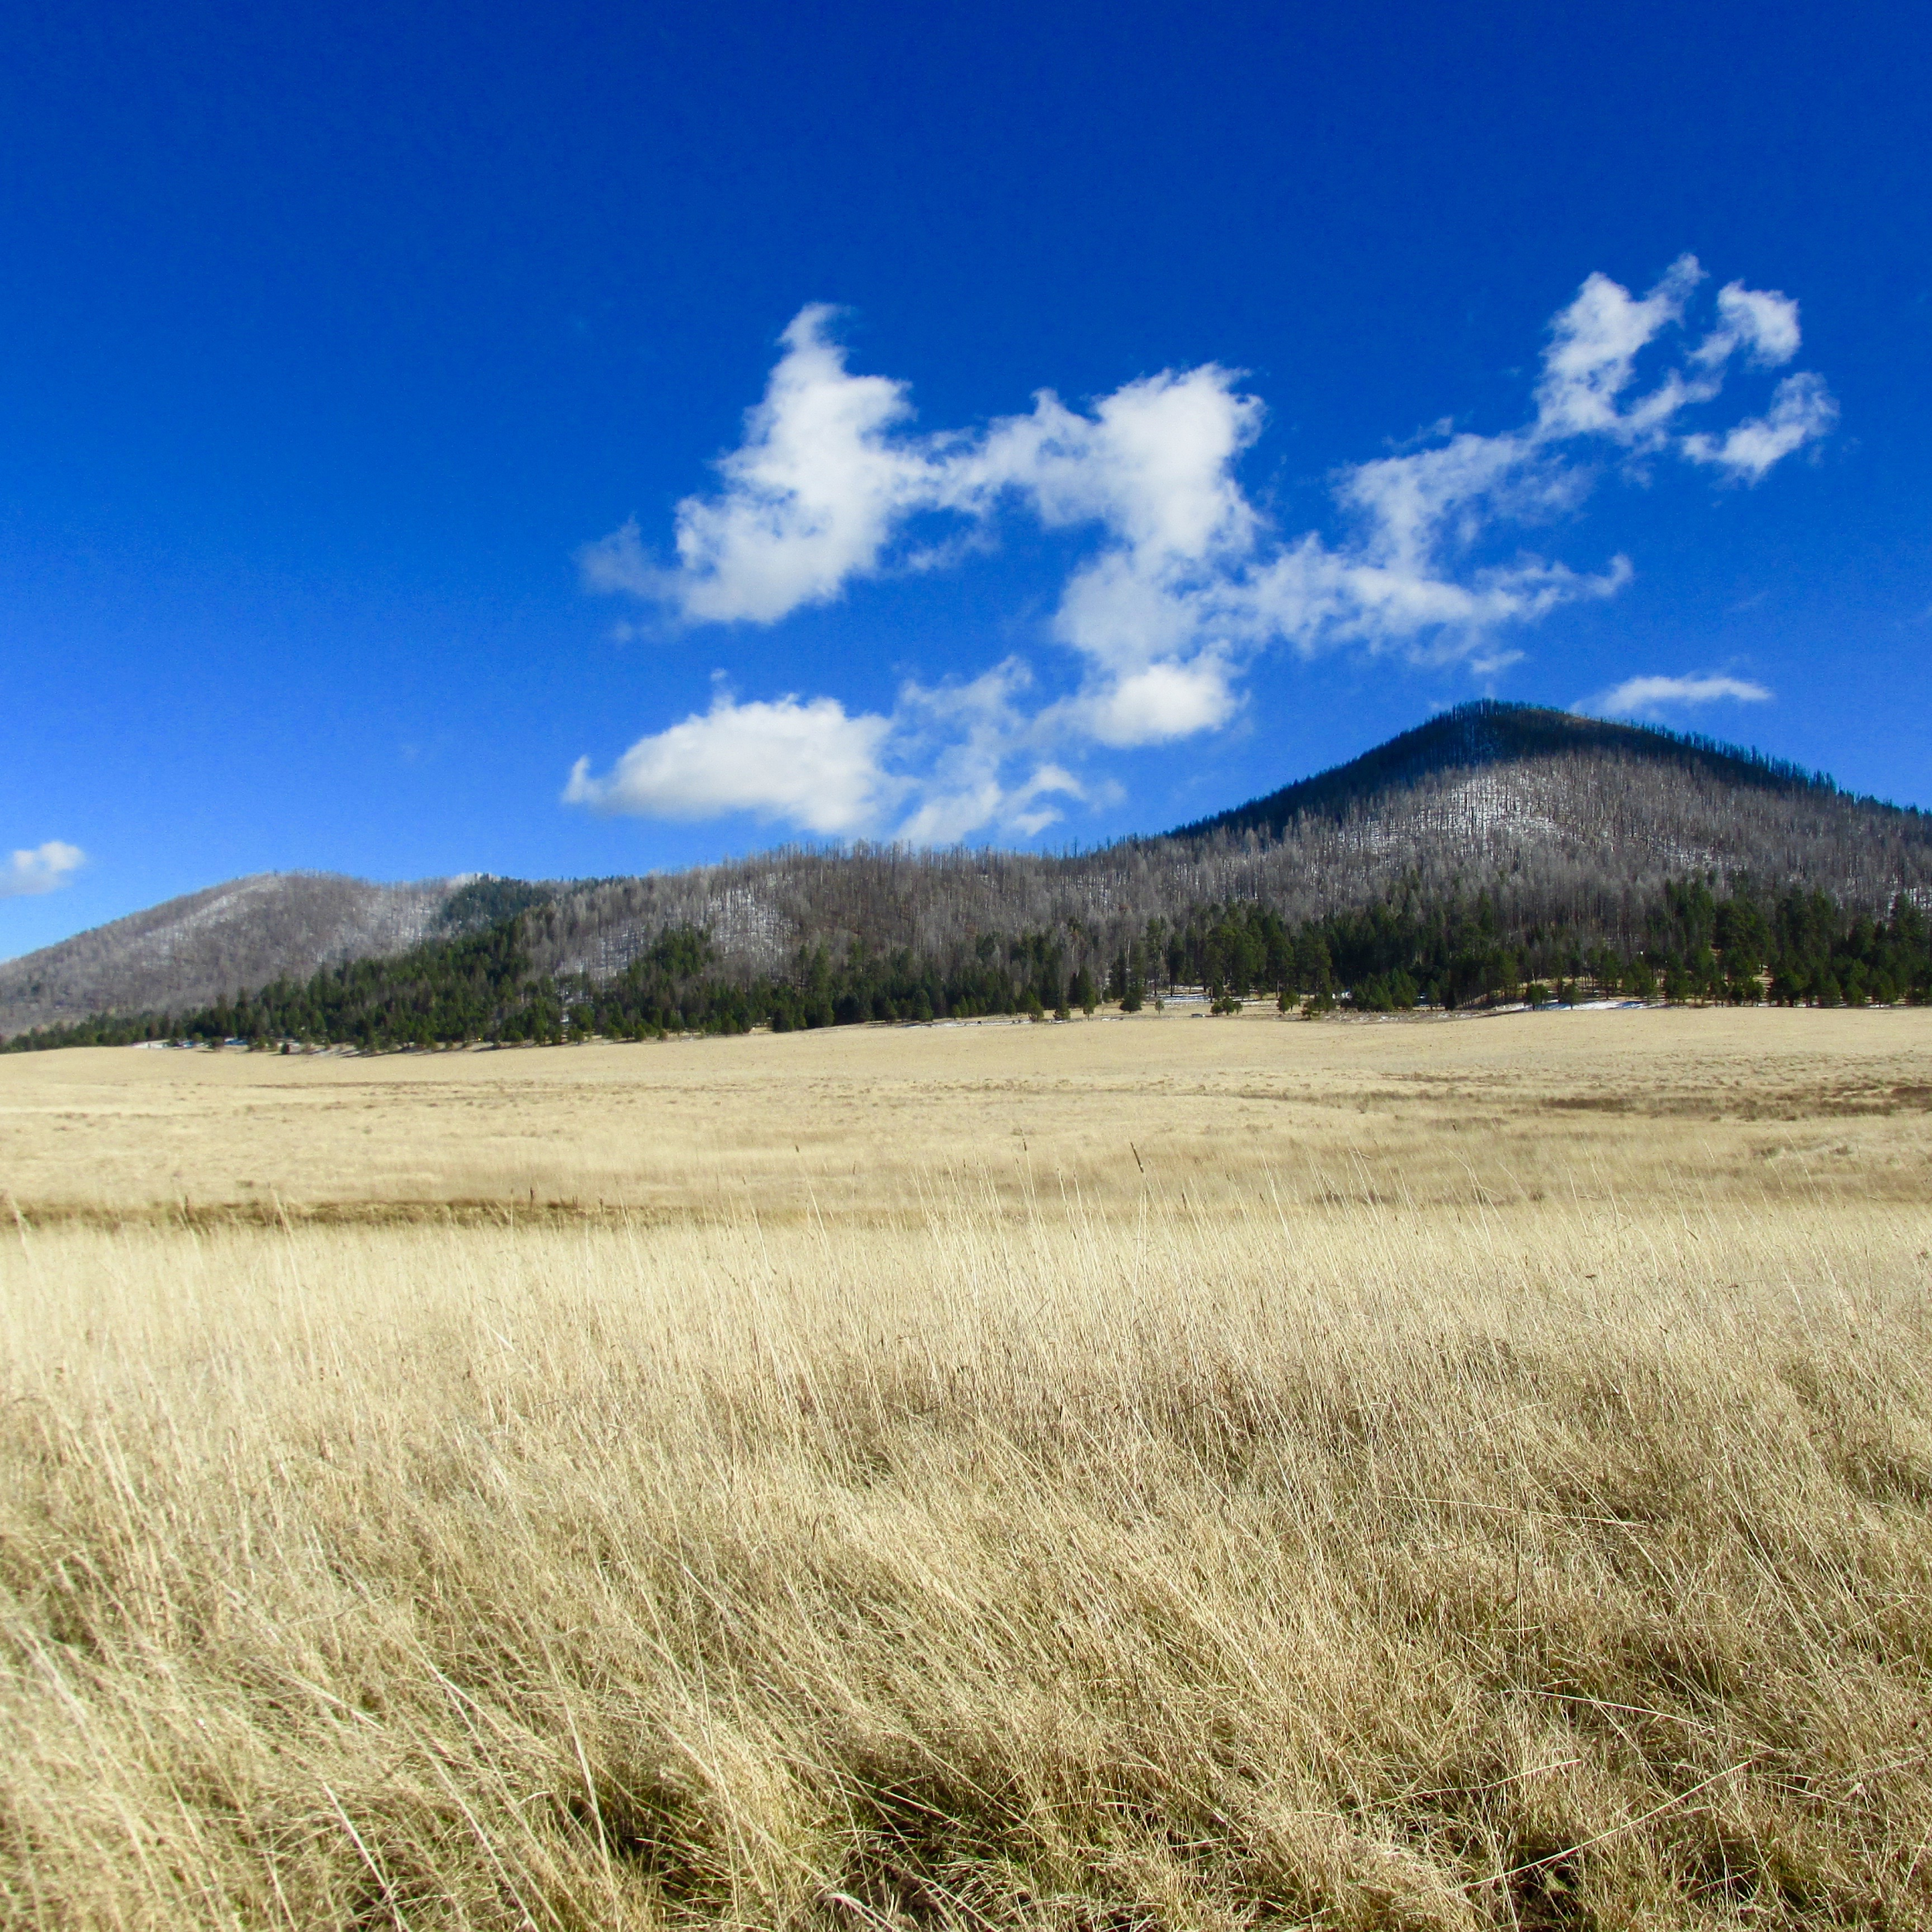
Grassland – Grasslands are primarily covered in grasses. Over half of the continent of Africa is covered in a tropical grassland, or savannah. Tropical grasslands are near the equator and have wet and dry seasons. The other type of grassland is called a temperate grassland. The temperature in a temperate grassland is cold in the winter and warm during the summer. During the spring and summer, there are many blooming wildflowers. In grasslands, there are few trees to hide or nest in.
Some animals that live in grasslands include: coyotes, mice, lizards, snakes, birds, and many types of insects.

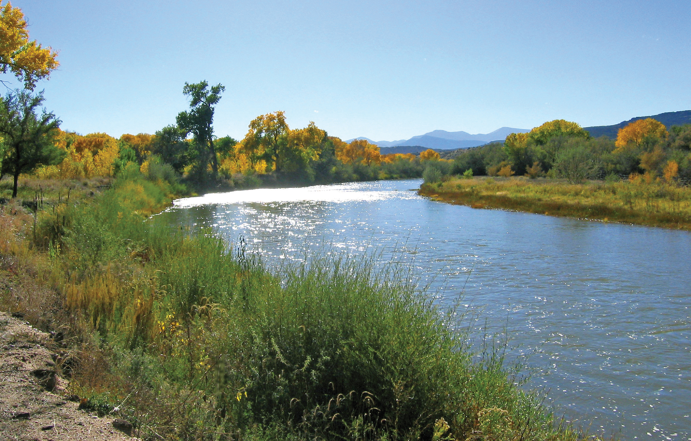

Aquatic – Water covers 75% of the Earth’s surface. There are two types of aquatic biomes, freshwater and saltwater. Freshwater fills rivers, lakes, ponds, and other inland areas. The area around the edge of the water can be muddy, sandy, rocky, or have lots of plants. Animals adapt to living in aquatic environments by being able to move through and sometimes breathe in water. Some animals that live in aquatic biomes include fish, insects, turtles, frogs, snails, and different types of birds. Many other animals come to aquatic biomes as a source of water.

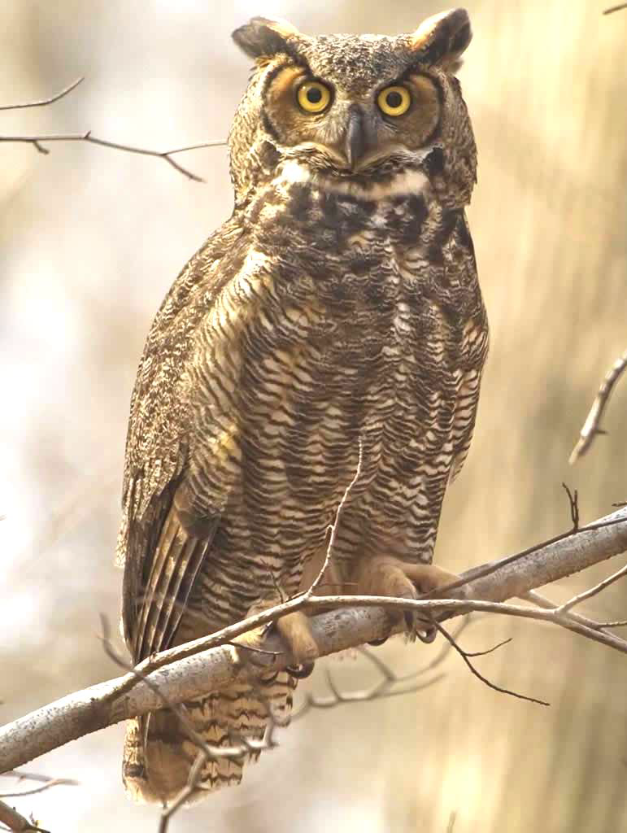  Great Horned Owl | 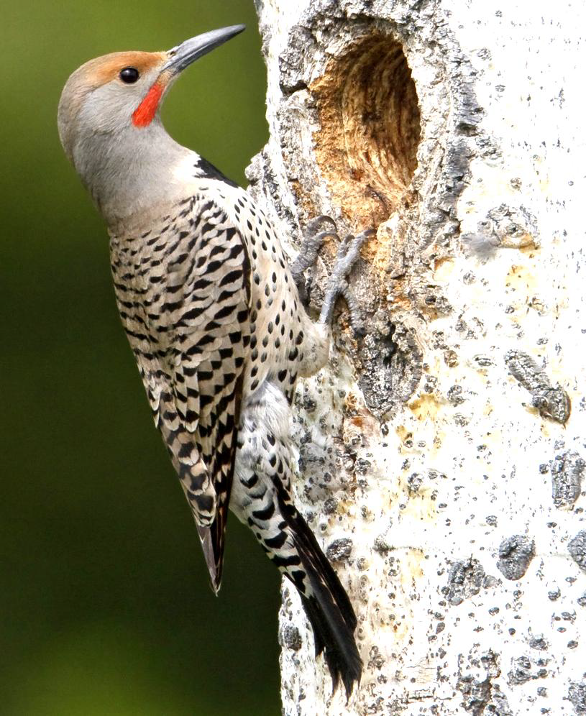  Northern Flicker
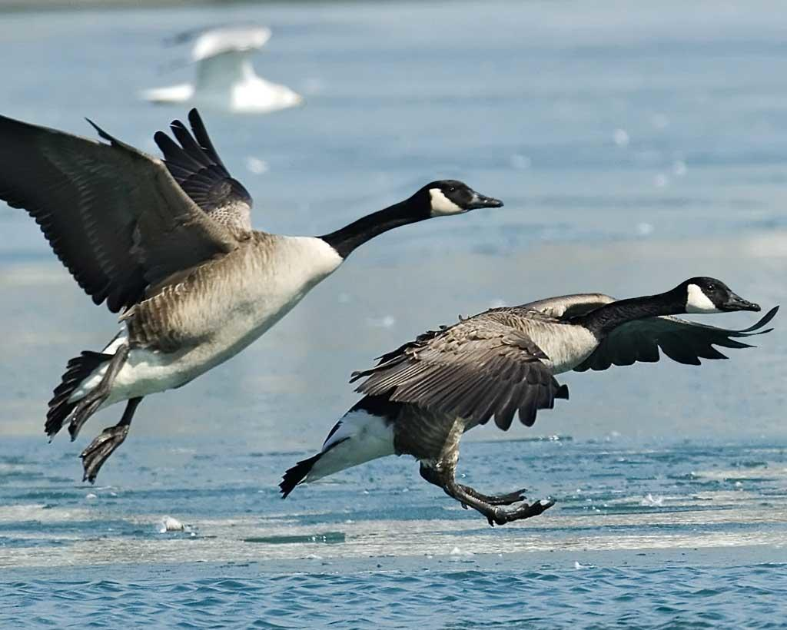  Canada Geese | 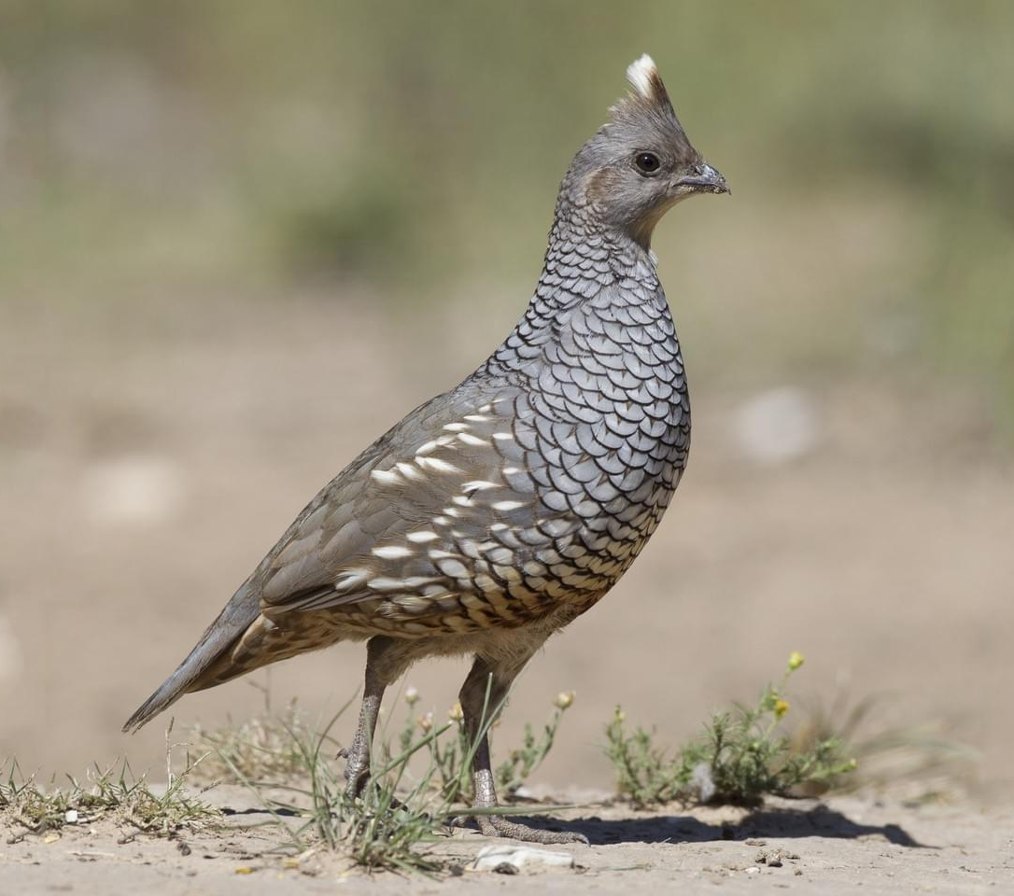  Scaled Quail

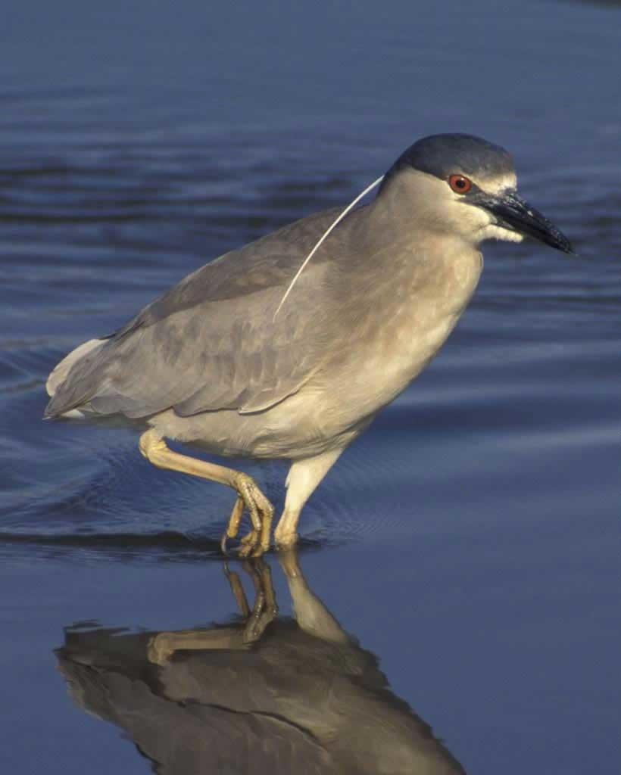  Black-Crowned Night Heron | 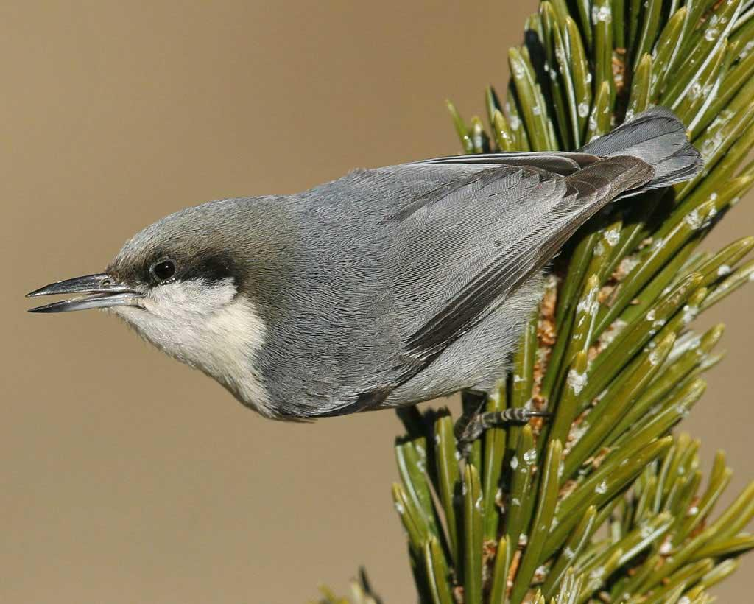  Pygmy Nuthatch
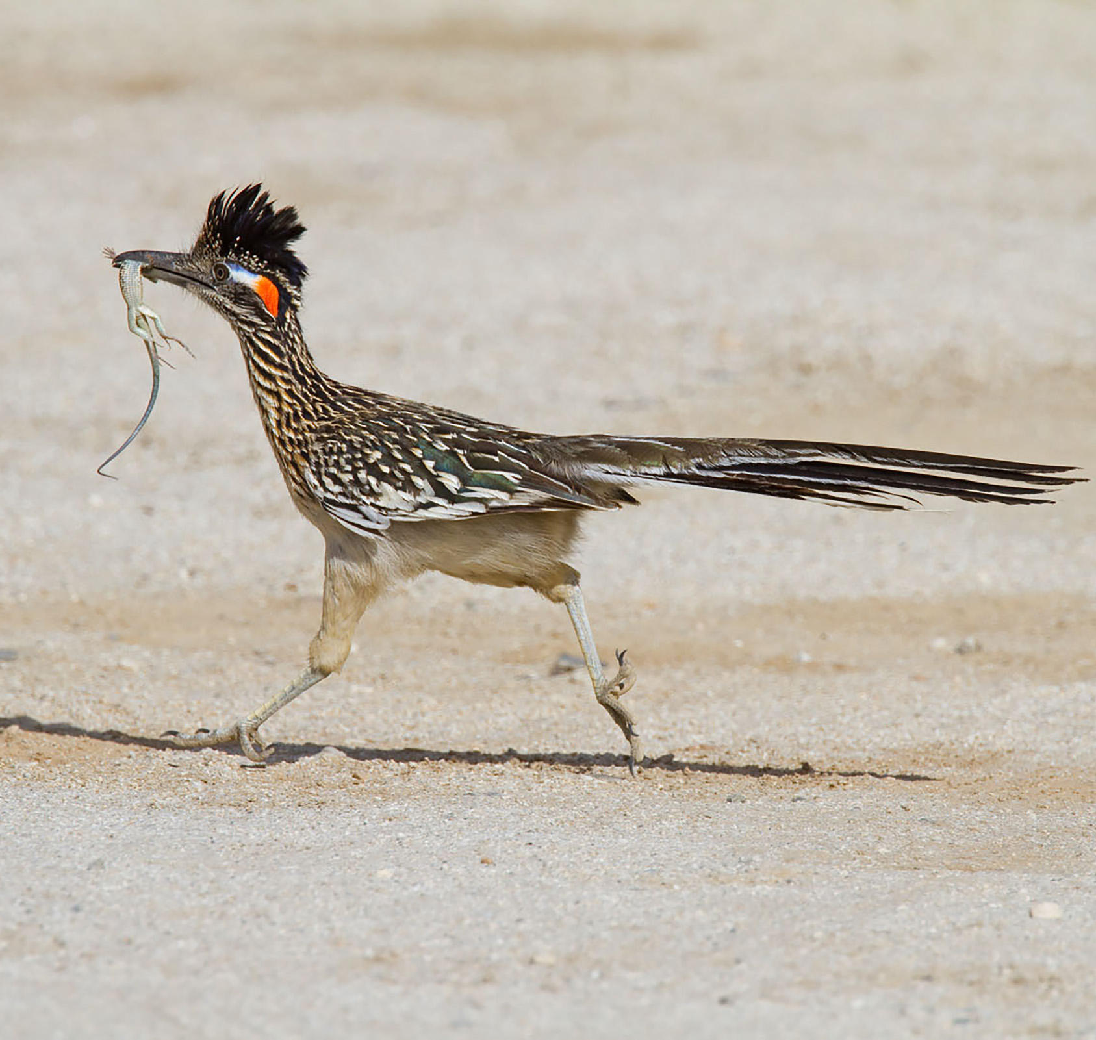  Greater Roadrunner | 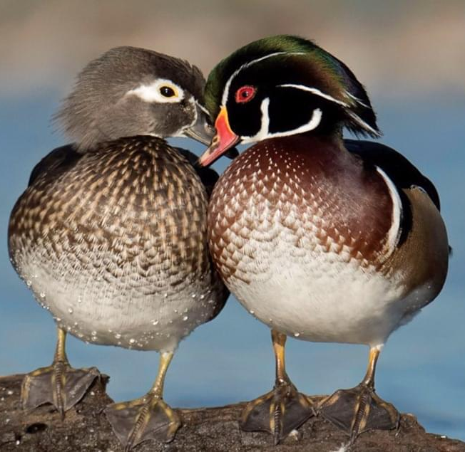  Wood Duck

