Investigation 1, Lesson 5-Migration
Focus Question: How do birds’ brains help them survive?
¿Cómo los cerebros de los pájaros les ayudan a sobrevivir?

*This lesson can be done before or after the Audubon Field Trip.*
Time Estimate: 1-2 hours

Concepts:
• Animals use their brains to process information and respond accordingly in order to survive (for example, migration, finding their way, fleeing predators, hunting)
- Los animales usan sus cerebros para procesar información y responder de una manera que les ayuda a sobrevivir (por ejemplo, migrar, no perderse, huir de los depredadores, cazar)
• Some birds migrate when the weather changes and their energy source (food) decreases.
Algunos pájaros emigran cuando el clima cambia y sus fuentes de energía (comida) disminuyen
• Different birds have different migration patterns.
Diferentes pájaros tienen diferentes patrones de migración

Vocabulary-
- Sensation sensación
- Process procesar
- Response reaccionar
- Flock bandada
- Migrate migrar

Materials:
- Birds Take Flight leveled reader from ReadyGen, also available in Spanish
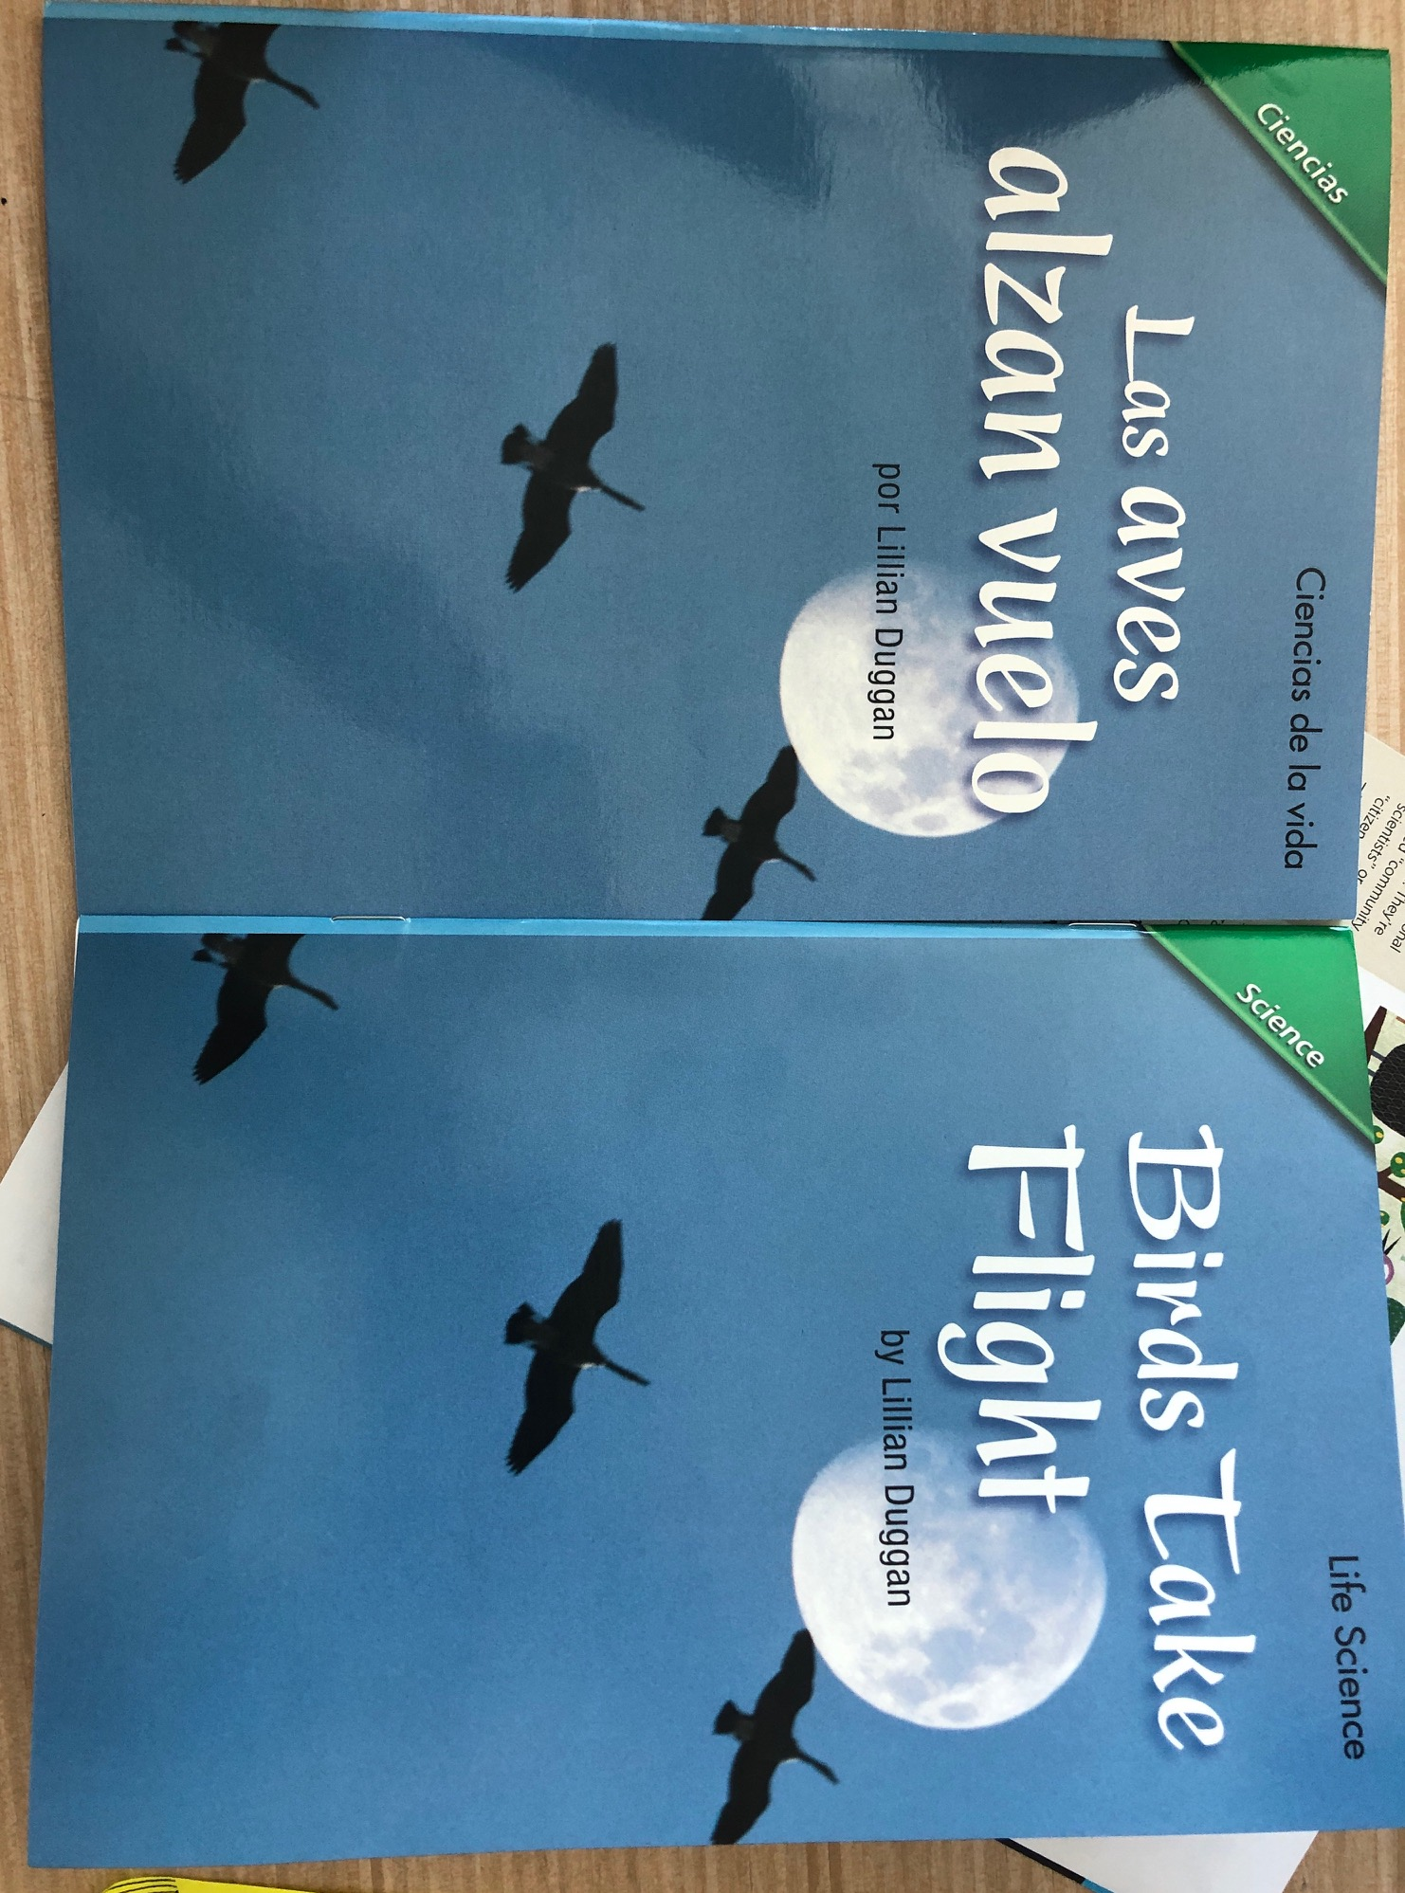

- Science notebook
- Writing Utensil
Links to NGSS and CCSS:
• NGSS: 4-LS1-2: Information Processing: Use a model to describe that animals receive different types of information through their senses, process the information in their brain, and respond to the information in different ways
• LS1.D DCI:Different sense receptors are specialized for particular kinds of information, which may then be processed by an animal’s brain. Animals are able to use their perceptions and memories to guide their actions.
• ELA:
- CCSS.ELA-LITERACY.RI.4.3
Explain events, procedures, ideas, or concepts in a historical, scientific, or technical text, including what happened and why, based on specific information in the text.

Point of Engagement:
- The Hook- Solicit adaptations students are familiar with. Most will name physical adaptations. Use human example for winter adaptations (wear warm clothes) and ask students what birds do during the winter.

Solicita adaptaciones con las que los estudiantes estén familiarizados. La mayoría nombrará adaptaciones físicas. Use el ejemplo humano para las adaptaciones de invierno (ponerse un abrigo) y pregunte a los estudiantes qué hacen las aves durante el invierno.

- Birds adaptations are not just their body structure, but also their behavior. Birds respond to changes in their environment and move from place to place to meet their needs. Students brainstorm animals they know that migrate annually (whales, fish, caribou, monarch butterflies, birds, and people)
Las adaptaciones de las aves no se limitan a su estructura corporal, sino también su comportamiento. Las aves responden a los cambios en su hábitat y se mueven de un lugar a otro para satisfacer sus necesidades. Los estudiantes intercambian ideas sobre animales que saben que migran anualmente (ballenas, peces, caribúes, mariposas monarcas, pájaros y personas)..
- Why would animals want to migrate? Temperature, food availability, space to breed/nest/raise young. How do animals know when to migrate?
  - When geese migrate in the spring, they fly north where there is more space to breed. In the fall, when the weather gets colder and the food gets scarce, geese fly south.
¿Por qué podrían querer migrar los animales? La temperatura, disponibilidad de alimentos, espacio para reproducirse/anidar/criar jóvenes. ¿Cómo saben los animales cuándo migrar?
Cuando los gansos migran en la primavera, vuelan hacia el norte, donde hay más espacio para reproducirse. En el otoño, cuando el clima se vuelve más frío y la comida escasea, los gansos vuelan hacia el sur.
Pregunta de enfoque: ¿cómo los cerebros de las aves les ayudan a sobrevivir?

- Focus Question- How do birds’ brains help them survive?

Investigation:
- Set the purpose: Start a Sensory/Process/Response chart whole group using humans as example. This is a good opportunity to review the five senses
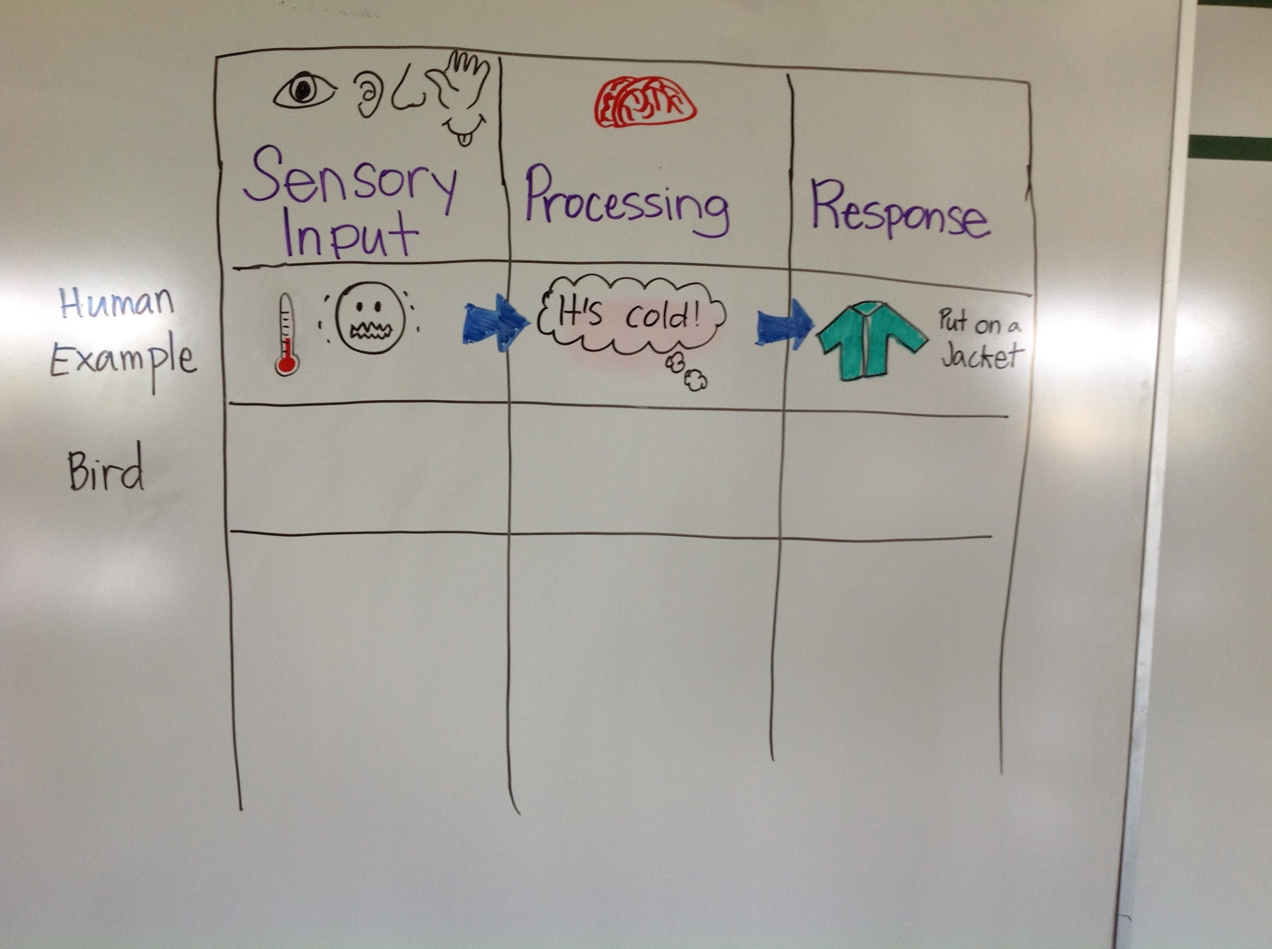

- Explain that we are going to read a text about Bird Migration. Teacher reads aloud text chunk, stopping to allow students to turn and talk in teams and fill in team chart on sensory input/processing/response
- información sensorial/procesar/reaccionar

Data Analysis/Evaluation:
- Meaning making circle
- Claims, evidence, and reasoning

Explaining and/or Solving: Answer the FQ

