Investigation 1, Lesson 1
What external features make a bird a bird?
¿Cuáles características externas hacen que un pájaro sea un pájaro?

Time Estimate: 1 hour

Materials: bird puppet, science journals, chart paper

Links to NGSS and CCSS:
- NGSS-
4-LS1-1 Construct an argument that plants and animals have internal and external structures that function to support survival, growth, behavior, and reproduction
Construir un argumento que las plantas y los animales tienen estructuras internas y externas que funcionan para apoyar la supervivencia, crecimiento, comportamiento y reproducción.

4-LS1-2 Use a model to describe that animals process the information in their brain, and respond to information in different ways.
Utilizar un modelo para describir que los animales procesan información en su cerebro y responden de diferentes maneras.

CCSS.ELA-LITERACY.SL.4.1.D
- Review the key ideas expressed and explain their own ideas and understanding in light of the discussion.
- Repasar las ideas claves expresadas y explicar sus propias ideas y entendimientos acerca de la discusión.

Vocabulary
external externo
features características
beak pico
feathers plumas
wings alas
feet patas
talons garras
crown corona

Point of Engagement:
- Costume or sandhill crane puppet (provided by Audubon)
- Focus Question: What external features make a bird a bird?
- What makes a bird, a bird? How do we know that this puppet is supposed to be a bird and not a cat/human/reptile?
- ¿Qué hace que un pájaro sea un pájaro? ¿Cómo sabemos que este títere se supone ser un pájaro y no un gato/ser humano/reptil
  - **All/only birds have feathers (most defining feature)
  - Todos/Sólo los pájaros tienen plumas
  - Birds have beaks specialized for what they eat
  - Los pájaros tienen picos especializadas para lo que comen.
  - Birds have wings, usually for flying but not always
  - Los pájaros tienen alas que usualmente funcionan para volar pero no siempre.
    - See Flightless Birds powerpoint for more info
  - Birds have feet specialized for catching prey, running, climbing, grabbing, walking, swimming
  - Los pájaros tienen patas especializadas para cazar, correr, trepar, sujetar, caminar, nadar,
    - Sharp claws used for catching prey are called talons

- Connections to prior knowledge: human bodies

Investigation:
- Create a pictorial input chart/anchor chart of the differences between a human and a bird.
Pictorial Input Steps:
Prior to class project image of comparative chart onto whiteboard to trace or freehand trace onto large chart paper. In class: Using color coding (ex: blue for birds/green for humans) color over drawing as you “lecture” and/or identify important information. Stop before changing species to give turn and talk time (ex: tell your partner something you noticed about the external features of birds)
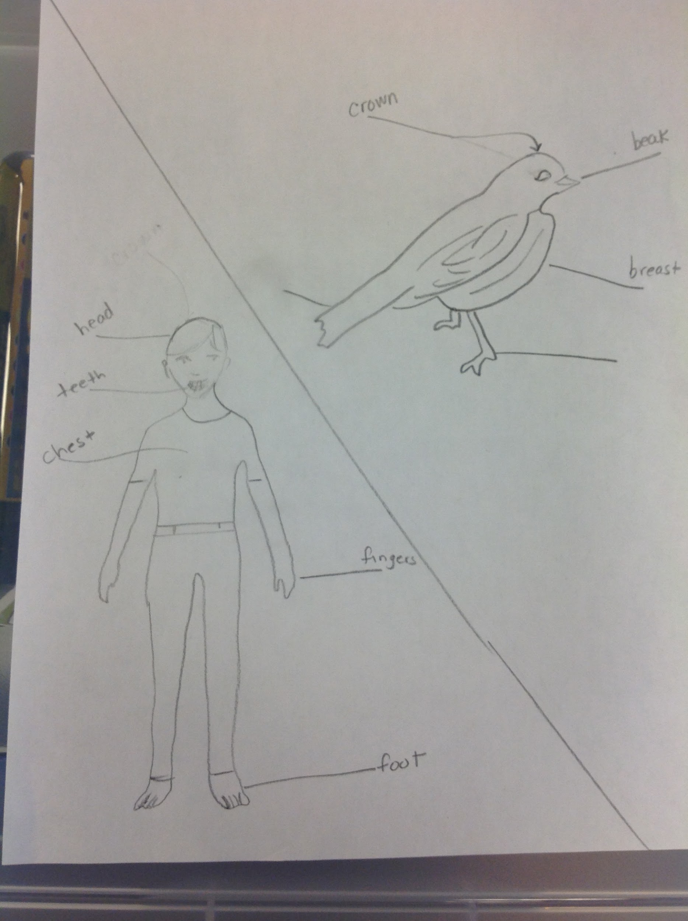

    - Birds have feet specialized for catching prey, running, climbing, grabbing, walking, swimming
    - The top of the head is called the crown.
    - Sharp claws used for catching prey are called talons
    - Turn and Talk (observations); vocabulary building; word wall Using the information from the input chart, students will complete individual “Physical Features of a Bird” activity sheet in their science journals.

Data Analysis/Evaluation:
- Meaning making
- See Flightless Birds powerpoint for more info when students claim “all birds fly”
https://drive.google.com/drive/folders/1_z0ZyG9fGr42K9nM6RaLgkCTirGxre3Y
- Claims, evidence, and reasoning
Guiding questions: Look at your data (prediction and drawing), what external features do birds have that make them different from other species?

Explaining and/or Solving:
Science Notebooking:
Use sentence prompts and vocab from word wall to have students compare/contrast humans and birds.
Ex: Humans have _________________, however birds _________________.
Ej: Los seres humanos tienen ____, sin embargo los pájaros _______.

